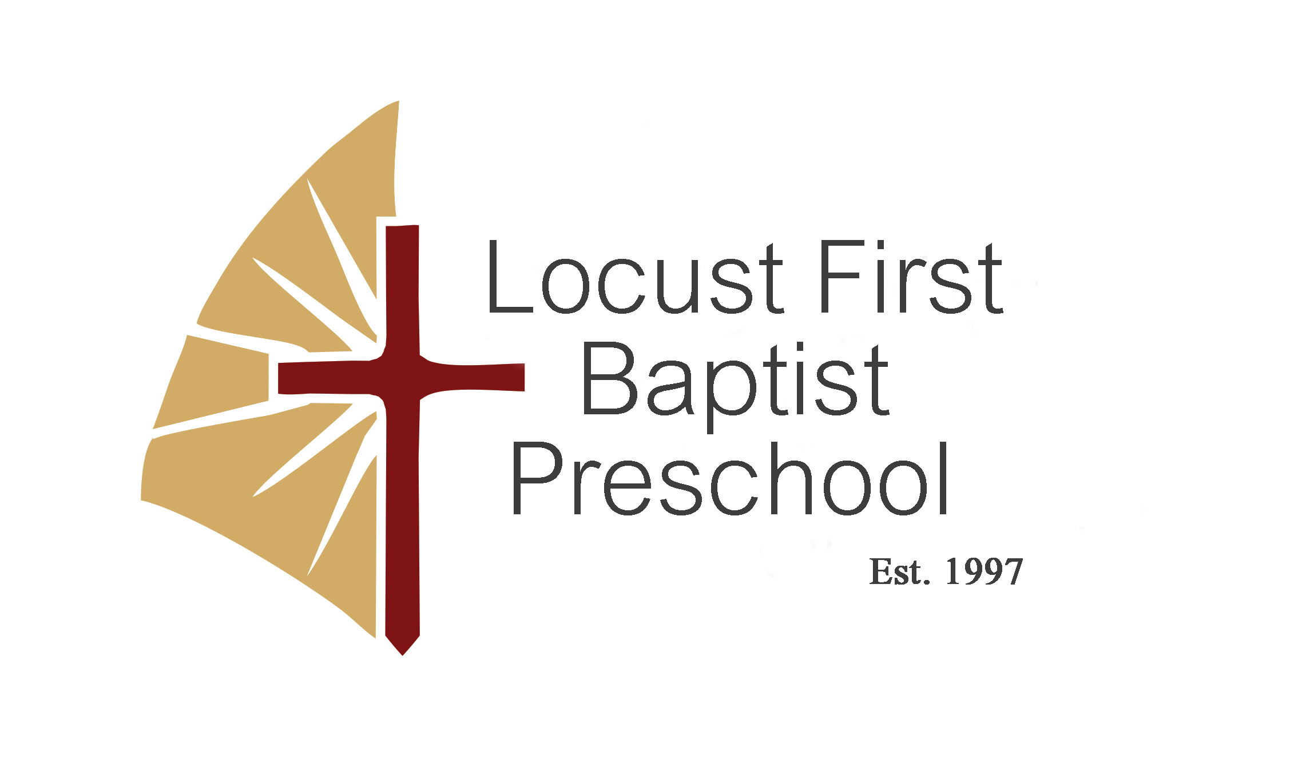

2024 -2025 School Year

Jody Waksmunski, Director
Preschool Office (704)888-8802
Home (704) 485-2295
fbclpreschool@att.net

320 S. Central Avenue / PO Box 159
Locust, NC 28097
(704) 888-2431
www.firstbaptistlocust.com
 First Baptist Church of Locust

A ministry of First Baptist Church of Locust

Our Mission Statement

Locust First Baptist Preschool is a nonprofit educational organization committed to offering the community the Gospel of Jesus Christ through the nurturing of our children in a safe and loving environment and in cooperation with the Holy Spirit to help the children to grow cognitively, socially and spiritually.

Welcome to

Locust First Baptist Preschool

We are eager to serve you in our Preschool Program. Your child will learn many new things, especially the love of Christ. We will strive to provide a caring, loving and secure environment for your child.

Calendar Year and Program Hours

Calendar Year – September 3, 2024 – May 15, 2025

Preschool Program - Age 1 (max. 8 per class) three days
Age 2 (max. 10 per class) three days
Age 3 (max. 12 per class) three days
Age 4 (max. 14 per class) three days

Days - Tuesdays, Wednesdays, and Thursdays

Please do not bring your child before 8:50 am. Pickup time is promptly at 1:00 pm. Doors will remain locked during school hours. A late fee of $10.00 per every 15 minutes late will be charged per child if you fail to pick up your child on time.

Registration and Tuition
Our program welcomes children regardless of race, color, nationality, or religious background.

Registration fee- $100.00 (nonrefundable)
There is a $10.00 discount for each additional child in family.

Three Day Tuition - $ 225.00 a month

There is a 20% discount on tuition for each additional child in family. Tuition can be paid with cash or check at preschool office or you can go online to www.firstbaptistlocust.com under ministries tab find preschool page then pay with debit or credit card.



September through May tuition will be full price and there will be no tuition credit given when your child is out sick, is absent, or the preschool observes teacher professional days, holidays, vacation, inclement weather and early release days per the Stanly County School System Calendar. Advance annual payments are welcomed. Monthly payments are for your convenience and are due on the 1st of every month. You will receive a friendly reminder if payment is not received by the 5th. Please make checks payable to First Baptist Preschool. There will be a $25.00 late fee added to tuition if received after the 5th of the month, unless prior arrangements have been made with the director. If arrangements are not kept your child will be dismissed from the program. Your child may not return to preschool until your account is current.

There will be a $30.00 fee charged on all returned checks. If more than one occurrence, only cash or money orders will be accepted.

We offer a $100.00 referral credit to any family that refers you to our program.

Curriculum
Individual classrooms have a structured lesson plan from the curriculum ABC Jesus Loves Me. It includes Bible story and Bible verse memorization. Letterland Curriculum is used to help transition children into Stanly County School’s kindergarten curriculum. Children are taught the basics needed for school, such as colors, numbers, shapes, alphabet, phonics and sight recognition at age appropriate levels. We have music, art and technology classes weekly. Every classroom has a teacher and assistant certified in CPR and First Aid. Background checks are required for employment.

Lunch
Please pack your child a nutritious lunch with items that do not need to be heated. Don’t forget to include a drink. In order to cut down on waste please only send what they can eat.

Parent Involvement Policy
Family support and involvement is very important. There may be times when you are asked to help with a field trip or activities in your child’s class. Please check with your child’s teacher before sending special treats for any birthdays, holidays, or parties.

Discipline
You will receive a copy of our discipline policy with your registration form. Good behavior is encouraged at all times. Biting in unacceptable and will be dealt with on a case by case basis and could lead to dismissal from the program.

Clothing
Make sure your child has on comfortable clothing and closed toed shoes when he/she comes to preschool. We go outside daily, weather permitting. Please send a jacket when appropriate. Remember to mark all personal belongings with your child’s name. We ask you to send your child an extra set of clothes in a zip lock bag in case of an accident.

Health Information
A current immunization record is required prior to entering the program in the fall. Please update when shots are given. Teachers are not allowed to administer any medication to your child, except in special cases. A medical form must be provided by your doctor and filed at the preschool.

Please do not send your child if they are sick. Children should be free of fever, vomiting, or diarrhea for 24 hours, without medication, prior to returning to school.

Observance of Holidays, Teacher Workdays, etc.
We will follow the same calendar year as Stanly County School System observing all teacher workdays, holidays, vacation, inclement weather, and early release days. There will be no tuition credit given for these days.
When Stanly County Schools are closed due to inclement weather, our school will be closed. If Stanly County has a 2 hour delay we will start at 11:00 am. On early release days we will close at 11:00am. You should watch local news coverage, and visit our Facebook page in the event of inclement weather for school closings or delays.

Open House
Our Open House will be held Thursday, August 29, 2024 at 7:00. There will be an opportunity for you to meet your child’s teacher and see classroom. A parent folder will be handed out then. It will contain all the information you will need for preschool. Parents will then join the director in the sanctuary and she will provide information for the school year and to answer any questions. Reminders will be sent out the first of August.

We want to help your child understand God’s purpose, plan and love for them. Our desire is to help develop an appreciation for education and a love for learning.

Please contact the director if you have any questions or concerns.

Locust First Baptist Preschool is a non-profit organization and because of that, donations are greatly appreciated. We also try to raise money annually through fundraisers for the betterment of our Preschool facility. All parents/students are requested to participate.

